|  |  |  |  |
| --- | --- | --- | --- |
| **No.** | **Name** |  | **Section** |
| **1** | سلمي احمد عبد الشهيد محمد | 200327 | 6 |
| **2** | سلمي صبحي نبوي عبد الهادي | 200331 | 6 |
| **3** | زياد عبدالمنعم جابرأبو عجيزه | 200299 | 5 |
| **4** | سامح طارق محمد محمود غنيم | 200317 | 5 |
| **5** | سعيد أحمد سعيد دهيم | 200323 | 5 |

***Technical management:***

1. Presentation layer

-It is what the user will see or It is the interface that the user will interact with.

-who is responsible for it?

UI/UX designer

front-end developer.

1. Business logic layer

-This layer will deal with data by storing and displaying it, such as usernames and passwords, and displaying the user interface.

-who is responsible for it?

Back-end developer.

1. Database layer

-this layer will deal with a database stored on the server.

-who is responsible for it?

Back-end developer.

Individuals needed:

1-UI and UX Designer

-Ui (user interface) will be responsible for the look.

-UX (user experience) is responsible for a human-first approach to product design and focuses on full experience from users’ first contact to last.

-experience needed?

1-sketch

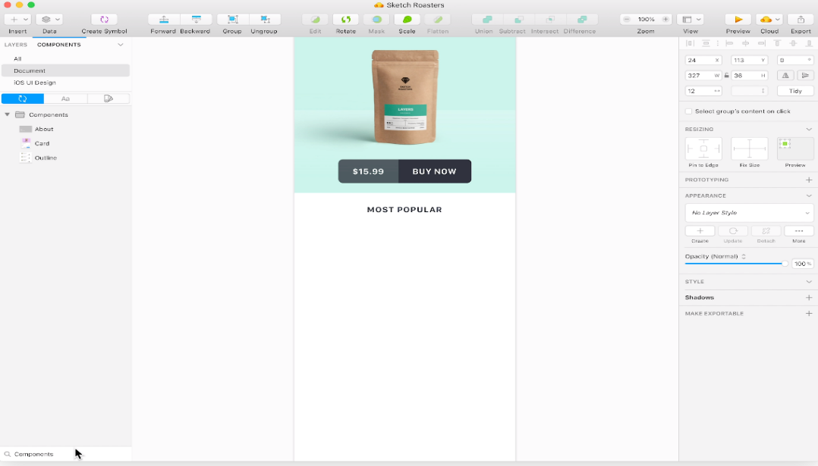

2-InVision Studio

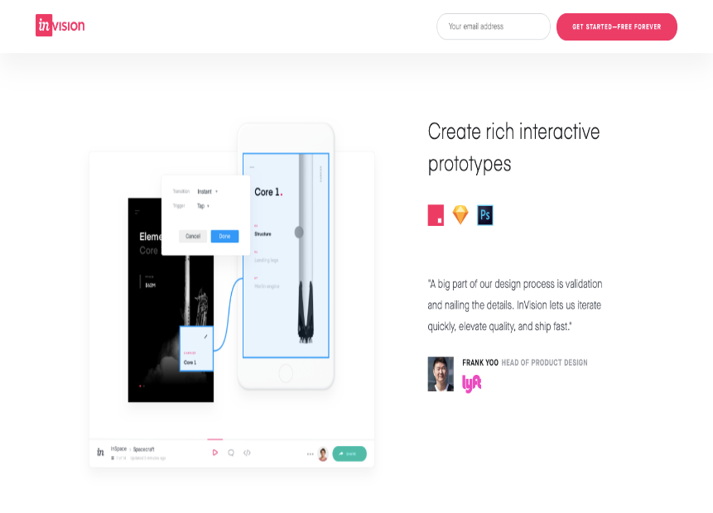

3-Axure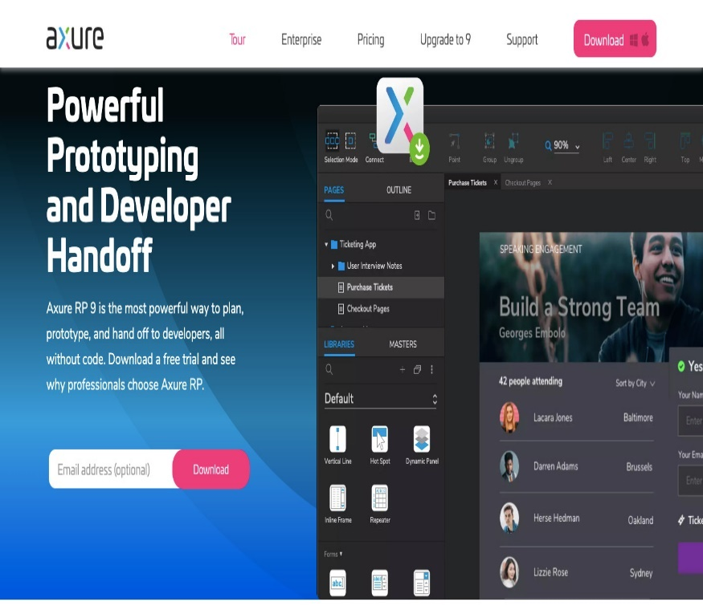

And more….

2-Front-end developer:

-He will be responsible for making user interface features, determining the structure and design of web pages, building the code, and optimizing page loading time by using markup languages.

- what experience is needed?

Html language

CSS

Java script

3-Back-end developer

-He is responsible for participating in the entire application lifecycle,

focusing on coding and debugging,

and write clean code to develop functional web applications,

Perform UI tests to optimize performance.

- what experience is needed?

Knowledge about front end

PHP language

Laravel framework

MySQL Git Git hub

4-Tester

-test and evaluate the performance of a site on the internet.

- what experience is needed?

Experience in test IO

**Feasibility study:**

**Economic feasibility:**

-**Budget**:30000

We expect that:

-the cost:

1-design:3000-5000

2-marketing: 3000-6000

3-backend: 4000-6000

4-host and domain:1000-4000

. total cost-->18000-21000

-**the tangible benefits**

. 200000 LE in the first year.

- The benefits may increase in the rate of 20% every year.

-**the intangible benefits:**

. Increase customer satisfaction

. Increased site recognition

. limit the time users take to reach information they want.

**Organizational Feasibility:**

. Our site provides information that will cover the needs of all people of all ages.

. Users can use the site easily as it provides an effortless way to find the answer to their questions because the first page in our site is divided into sections every section has information about each field and a search engine to write his question.

. Admins will have full access to the site and review the problems that the users face.

. Specialists will review all articles before sharing them on the site.

. This site has a minimal risk for the developers and marketing managers

are knowledgeable.

Project Description:

. The project (HOW TO)'s main purpose is to gather a huge amount of information (from all fields) in one place to

help people to find what they want quickly with a little research

. When we search about something the first thing we write is (how to ....) so users will find suitable answers for

their questions.

. The site allows users (writer-doctors-education-food and nutrition...) to share information and articles, but before sharing they are

reviewed by specialists.

. Users can evaluate the information on the site and communicate with the admin if they face any problem.

-Nowadays every person uses the internet and has a smart phone, so this site will be an innovative idea.

**Market feasibility:**

. Marketing manager will study Arrangements for marketing the site and supplying it with the necessary inputs for its operation.

. We decided to make the propaganda through funded advertisements on social networking sites and sites that allow advertisements.

. We can also market the site through influencers in fields that the site supports

Accepted Articles

Articles

User’s Article

Accept or deny

Solution

Problem

Article report

Article Report

Denied articles report

Denied Articles

New article

Send answer

Send question

Problem report

Problem report

Review or problem

Problem Solution

Article

Waiting

Ask for question

Answer

Solving existing

problem

Post a

problem

Publish new

Article

Review users

Articles

Post new

Article

Show

searching

result

Searching

process

D3 Problems File

D2 Articles to review

D1 Published Article

7

6

5

4

3

2

1

Admins

Specialists

Users

Context Level:

Denied articles report

Review or Problem

Problem Solution

Waiting

Article

Answer

Ask for question

Publish Article

Accept or deny

User’s Article

Problem

Solution

HowTo

System

0

Users

Specialists

Admins

Level 0

Users

Specialists

Admins

1

2

3

4

5

6

7

D1 Published Article

D2 Articles to review

D3 Problems File

Searching

process

Show

searching

result

Post new

Article

Review users

Articles

Publish new

Article

Post a

problem

Solving existing

problem

Answer

Ask for question

Waiting

Article

Problem Solution

Review or problem

Problem report

Problem report

Send question

Send answer

New article

Denied Articles

Denied articles report

Article Report

Article report

Problem

Solution

Accept or deny

User’s Article

Articles

Accepted Articles

**ERD**

solution

send

Admins

Send article

Control

Controlled by

review

problem

Send

 respond

ask

publisher

server

specialists

users

***financial management***

**There are two main categories of expenses to make a site:**

(1 Design and functionality: This is what people see when they visit your site, interact with your content, for example, the layout of your website will affect how long people stay on your site.

2) Infrastructure: These are the many expenses necessary to build and run your own e-commerce store, but things that your audience doesn't necessarily notice.

**Your success begins long before you publish your website. It starts when you create a plan for building your site, which includes a list of expenses and a budget.**

**As he broke down the ecommerce site cost question, you'll notice that the following expenses play a role for nearly everyone:**

- Domain name

- host

- Theme

- special design

- web development

- Setup expert

- Marketing and SEO

- Payment processing

- Applications and plug-ins

**1) Domain name :**

You cannot have a website without a domain name. This is the permanent address of your online store, so it is important that you choose wisely.

How much you pay for a domain name depends on a variety of factors, including:

- The recorder you are buying from

- TLD for your domain name (.com is the most common)

-If you are buying a domain for sale on the secondary market

**- In general, you can expect to pay $10 to $20 for a domain name at a registrar like GoDaddy or Namecheap.**

**- Tip-Confidential: Some web hosting providers give you a free domain name when you sign up for a new plan.**

**2. Hosting costs :**

Hosting is the driver behind your online store. It is essential to make your website accessible to outsiders.

**You have two basic options:**

- Host your e-commerce website.

- Use an ecommerce platform that includes hosting (SaaS).

**Prices vary from company to company and plan to do so, but you should budget between $5 and $20 a month.**

* **If you choose to build your store with a popular e-commerce platform, such as Shopify, your hosting is included with a variety of other features. Shopify has three options:**

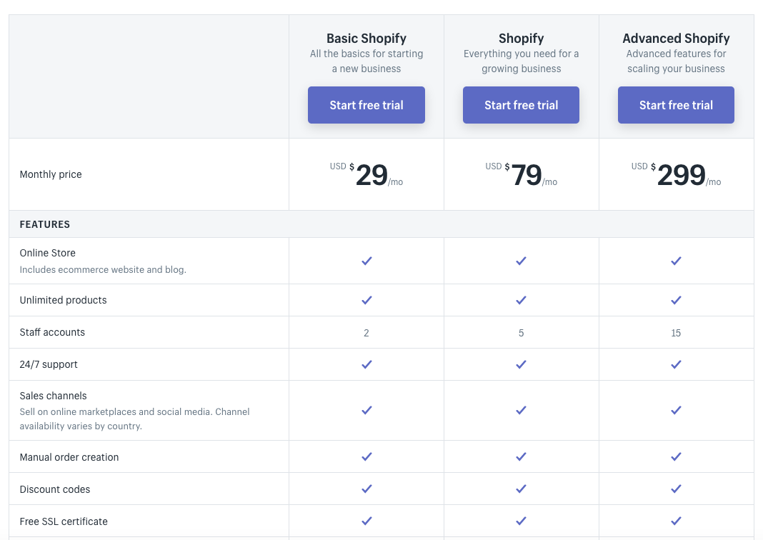

**3. Theme :**

- We suggest starting your search on the Shopify theme store, as they outline all of your choices, both free and paid. A quick search shows that a budget from $160 to $200 will give you plenty of options.

- So, when it comes to the cost of a theme for your online store, it ranges from free up to about $200.

**4. Custom website design cost :**

The only thing likely to hold you back is the cost of a custom design. The cost varies based on the size and scope of the project, but expect to spend a minimum of $1,500 to $5,000. And if you're more interested in designing at the enterprise level, completing a myriad of internal pages - like products and categories - you'll easily cost anywhere from $10,000 to $50,000.

**5. E-commerce website development cost :**

**Some of the things a developer or web development company might hire include:**

**-** Fill your online store with product descriptions and images.

- Implement and/or customize the checkout system.

- Create a custom app or plugin.

* Website icon customization.

**Prices vary based on experience, platform, project scope, and location. On the low end, expect to pay somewhere in the $15-30 an hour. But for more advanced projects, like custom coding, $150+ is out of the question.**

**6. Setup Expert :**

This person is not necessarily a designer or developer. Instead, they are experts at building e-commerce websites from scratch. They know many platforms inside and out, which allows them to provide guidance or complete the entire task for you.

The platform you chose has a lot to say about how to choose a setup expert for your e-commerce site. This is one of the biggest benefits of using Shopify, because they have a great guide of setup experts who are ready to help you.

**Expert assistance starts at $500 but goes up to a maximum of $15,000+. You can search by budget, country/region and languages ​​spoken to narrow down your options.**

In addition, each provider has a profile that states their experience, services provided, number of jobs completed, and reviews. You can also request a custom quote for your project.

**For a basic setup on Shopify, budget from $500 to $1,000. If your needs are more complex, it will likely take you $1,000 or more to get everything you want.**

**If you're on a different platform or don't want to use the Shopify Marketplace, you can hire a freelance setup expert, such as through Upwork or another freelance platform. In this case, you can find someone at a similar cost to a developer, with a starting price of $15/hour.**

**7. Marketing and SEO :**

You can create the largest e-commerce website in your space, but it doesn't do you any good without traffic. You need people who visit your site, interact with your brand, and share their positive experience with their network.

This is where marketing and SEO come into play. If you are launching an online store or want to achieve better results with the store you currently have, a marketing strategy is a must. This includes but is not limited to:

Marketing content

blogging

social media

Email Marketing

word of mouth

Pay-per-click (PPC)

Search Engine Optimization Services

**Besides the above, you should set a budget. It doesn't matter if it's $100/month or $10,000/month, knowing what you can spend will help you plan accordingly.**

Marketing

The main benefits and competitive advantages of the site..?

When the customer needs to search for a specific thing, he searches for it, for example, in Google, he searches for it on a site, and the second may not find it complete, and this of course takes a very large time to meet the need that he needs

We were able to provide the most valuable thing to the customer, which is his time, and we were able to collect all the information he needs in one site, but this is by choosing the field that he needs, such as sports, programming, or others. He searches for what he needs, shows him articles, links to videos, and explanations, and that's how we saved It takes a lot of time and effort

how to do website marketing

1. Marketing through social networking sites

We will need to be present on every digital marketing channel that this audience has, such as Facebook, Instagram, Twitter, Snapchat, and others.

Social media platforms are among the most important online sales channels and channels that allow you to market and promote yourself in more than one way and a different strategy for your product and make it easier for you to reach a huge segment of the online shopper audience.

2. SEO Marketing by Search Engines

One of the most successful free marketing methods for products online is to take advantage of search engines. Millions of searches are made daily on goods from products, services, and others through different search engines, the most important of which is Google, which is the primary destination for anyone when they search

About any matter, whether a commodity, a question, or a problem

Marketing through search engines is divided into two parts, the first is marketing through paid ads, the most important of which is Google ads, and this is done

Through the Google Adwords platform

. SEO Part Two is what defines your ranking as a dance in search engine results

The most important goal that SEO strategies can help you achieve is that your products and services reach your target audience who is already interested and searching for what you offer.

3. Create advertising campaigns

Creating paid advertising campaigns is considered the fastest way to market products over the Internet, as it ensures access to a huge segment of the user audience, whether through the Google search engine or any of the social media platforms such as Facebook, Instagram, or Twitter, etc.

the people targeted by the site….

We target young people from the age of 18 to 49

When we surveyed people who use the Internet and social networking sites, we found that

The age group that uses social networks daily is those aged between 18-29 years, with a percentage of 84 percent.

It is immediately followed by the category of 30-49 years after it with a rate of 81, which increases the chance of the project's